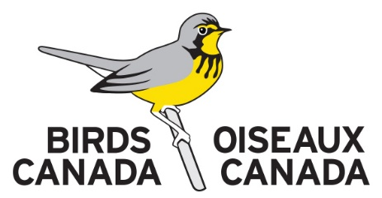
Long Point and Thunder Cape Bird Observatory
Cooperator Health and Safety Form
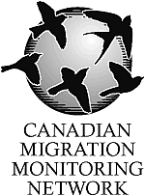
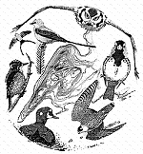
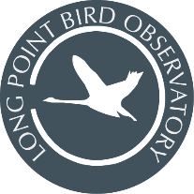

Return to: Long Point Bird Observatory, P.O. Box 160, Port Rowan, ON Canada N0E 1M0. 519-586-3531 lpbo@birdscanada.org | www.birdscanada.org/lpbo

Or, Thunder Cape Bird Observatory, Thunder Cape Bird Observatory
c/o Thunder Bay Field Naturalists
P.O. Box 10037, Thunder Bay, Ontario P7B 6T6. 807-251-3673
arbyboardman@gmail.com | https://tbfn.net/thunder-cape/

All information will be kept confidential and is only used to ensure the health and safety of cooperators.

Name: | Citizenship:
Address:
City: | Province/State:
Postal or Zip Code: | Country:
Phone: | Email:
Emergency Contact Name: | Phone No.:
Do you have a valid driver's licence? | Province/State/Country:
Do you have up to date life saving, CPR, or first-aid training?
Do you have any physical or mental health conditions requiring treatment, medical supervision, or that may be of concern to staff responsible for your safety in very remote locations? If yes, please provide details.

Do you have any dietary preferences or restrictions?

Are you prepared to share a bedroom with others?

I agree to share in routine chores and maintenance of the facilities and equipment as needed. Please initial.

I have read and agree to the expectations within the Covid-19 Policy and Procedures. Please initial.

Comments or other important information.

By signing this form, you affirm that you have provided us with all information necessary to provide a safe work environment for you and other cooperators. You also agree that you have read, understand and will abide by all rules, regulations, and guidelines found within the LPBO/TCBO Fact Sheets, Health and Safety Manual including Covid-19 Policy and Procedures, and Program related Protocols.
Signature: | Date:

BY SIGNING THIS DOCUMENT YOU MAY BE WAIVING CERTAIN LEGAL RIGHTS, INCLUDING THE RIGHT TO SUE. PLEASE READ CAREFULLY!

ACKNOWLEDGEMENT AND ASSUMPTION OF RISKS
AND
RELEASE OF LIABILITY BY ________________________
Name of Volunteer (the "Releasor")

Address: _____________________________________________________
Telephone: ____________ Fax: ____________ Email: _____________

With respect to the Volunteer's participation in the activities and field programs (the "Program") carried on by BIRDS CANADA (the "Releasee"), at and/or connected with Long Point Bird Observatory at Long Point, Ontario, Thunder Cape Bird Observatory at Thunder Bay, Ontario, or elsewhere, the undersigned Releasor on behalf of him or herself, heirs, executors and legal guardians, hereby acknowledges and agrees as follows:

1. To assume all risks pertaining to the Program which may include but are not limited to, traveling by boat, back country travel and living, and field work and the use of Birds Canada facilities in field locations from which communications may be difficult and that rescue and medical treatment may be delayed.

I also acknowledge that the Program may be carried on in areas where there may be some health hazards including a risk of contracting Lyme Disease.

2. That I have received, read and understood the operations manual provided to me by Birds Canada with respect to its safety and operations rules and regulations pertaining, but not limited to, wearing a government approved personal flotation device while in a watercraft and the health risks associated with and some precautions against contracting Lyme Disease.

3. That I am not an employee, servant or agent of Birds Canada.

4. That I will abide by all Federal, Provincial, Municipal or any other law pertaining to said activities participated in by me.

5. That I hereby waive, release and indemnify BIRDS CANADA and each of the respective directors, officers, employees, servant and agents, professional advisors, independent contractors and consultants and their successors and assigns (the "Releasee") from all manner of actions, suits, loss or injury of every nature and kind arising, including death, from my participation, either directly or indirectly in any Program of the Releasee except to the extent that same were caused by the negligence or default of the Releasee.

6. I hereby acknowledge that I have been advised by Birds Canada seek independent legal advice and have had sufficient time and opportunity to do so prior to my executions of this document and I hereby acknowledge that I fully understand the terms of this documents and there has been no representation of fact or opinion, threat or inducement which has affected my decision to execute this document.

7. To the best of my knowledge I have fully disclosed my medical problems and disabilities and dietary restrictions which are listed below:

8. This document shall be interpreted in accordance with the laws of the Province of Ontario.

Dated this ___ day of _____________, 20____.

Volunteer's Name: _________________________ ____________________________
(Please print name) (Signature)

*Witness Name: _________________________ _____________________________
(Please print name) (Signature)
*Parent or Guardian if Volunteer is under 18 years of age

Birds Canada: ___________________________ _____________________________
(Please print name) (Signature)

Witness Name: _________________________ _____________________________
(Please print name) (Signature)

